Procurement Plan List :

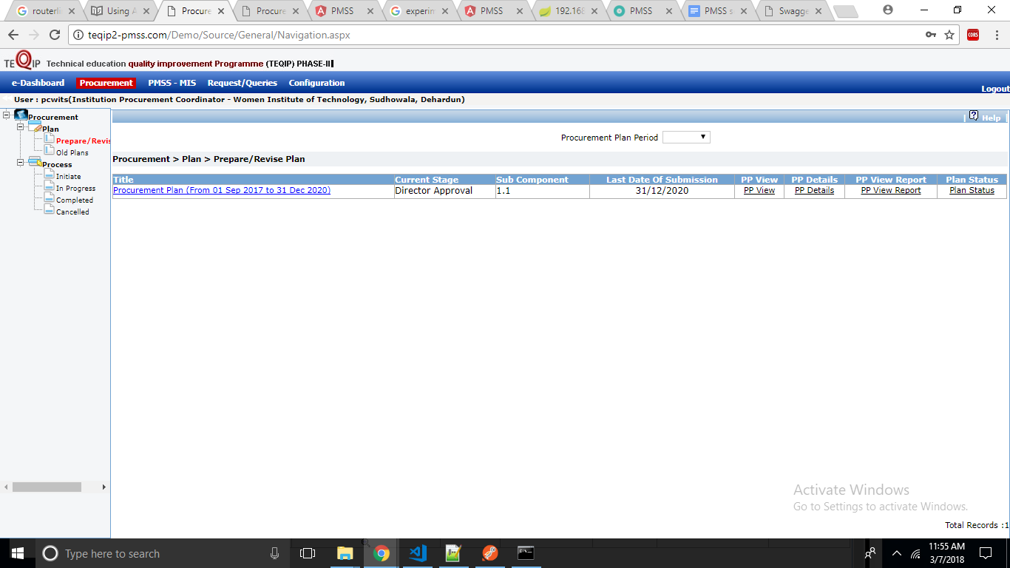

1: <http://192.168.1.114:8081/pmss/reference/plan?userId=1> GET

Service & goods both

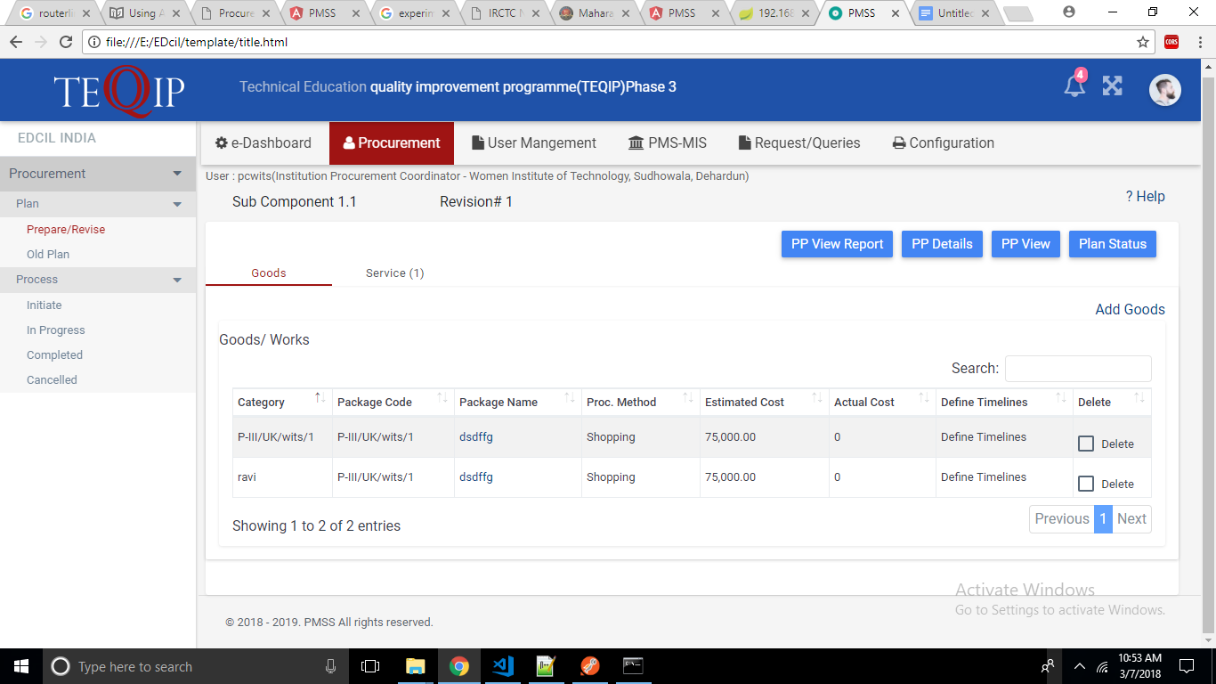

2: <http://192.168.1.114:8081/pmss/reference/procMethods> GET

Drop down

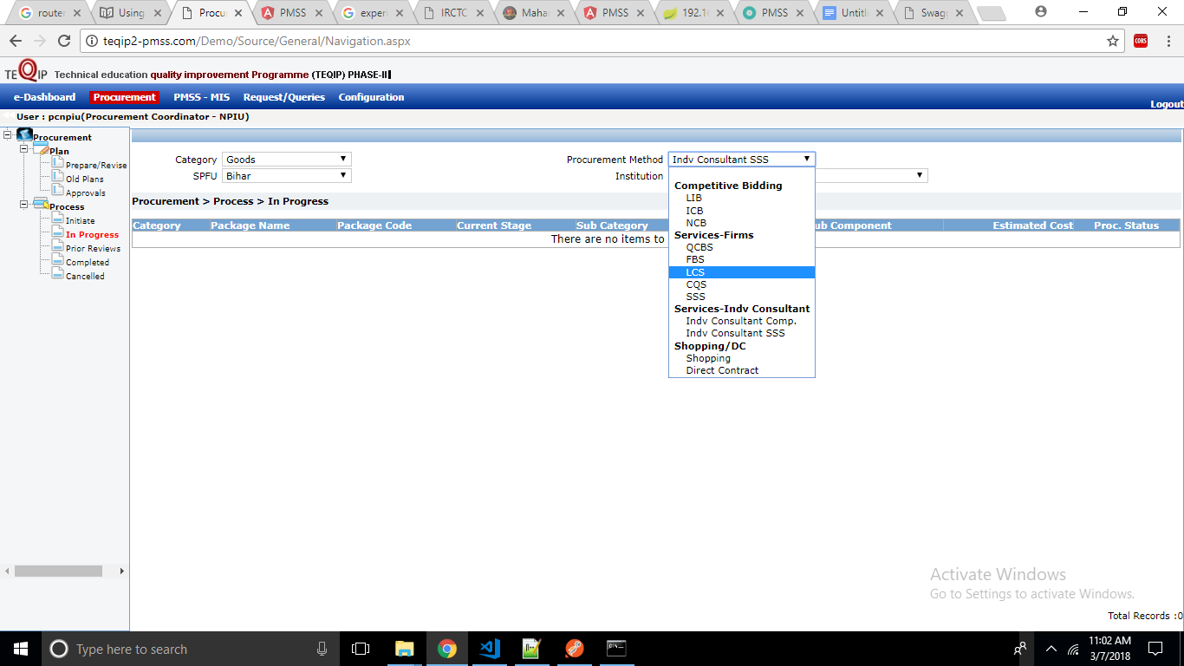

3: <http://192.168.1.114:8081/pmss/reference/activity?categoryId=1&userId=1>

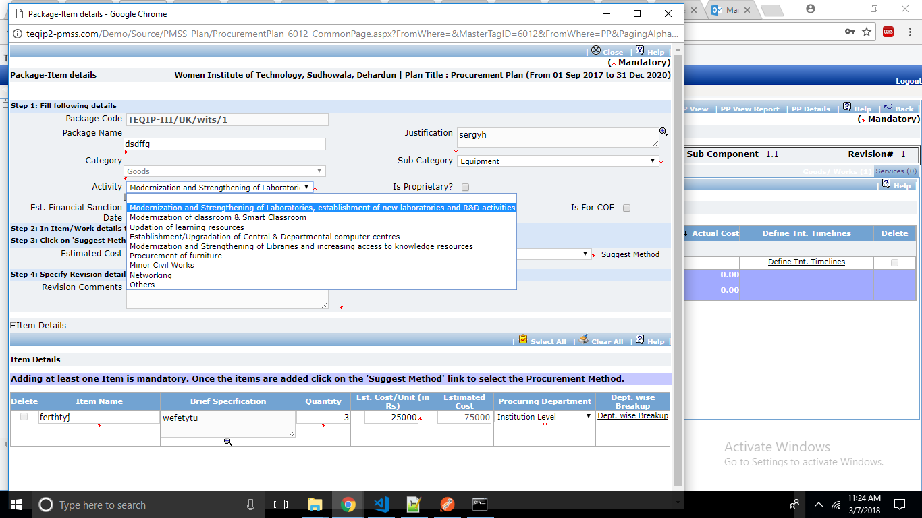

4: Create Packages

<http://192.168.1.114:8081/pmss/package> POST

5: Get Packages